 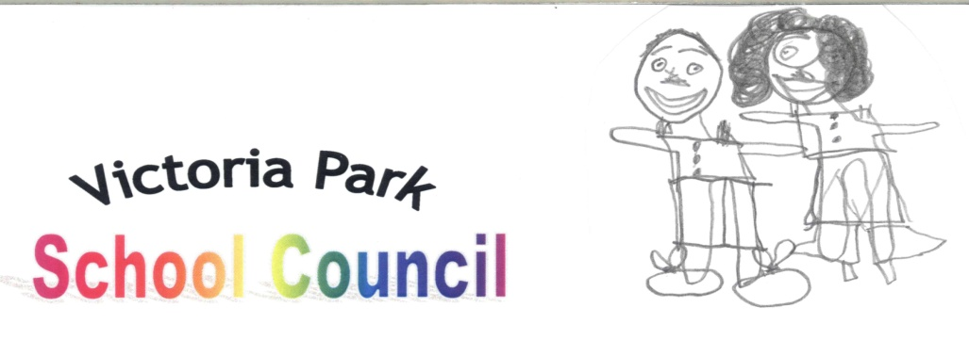

8th February 2016

Dear Parents/Carers,

We are going to raise some money by holding a non-uniform day and it will cost 50p. It is going to be on the Thursday 11th February 2016 for Valentine’s Day. We are inviting your child to wear any suitable red clothing. We need you to support us so we can improve our school and so we can buy equipment for the children.

This non-uniform day will be for everyone, so please remember to bring 50p to help us raise some money.

We would like your child/ren to give their money to their Class Teacher on Wednesday 10th February 2016.

Please show us your support and remember that all the money raised will go towards helping your child at school.

We would like to thank you for your support with this event alongside Mrs Mahal, the School Council Leader.

Yours sincerely,

Aaliyah Downie (6A) Tamara Tatarova (5B)

Chairperson of School Council Vice Chairperson of School Council